Opportunities and Resources for Online Participation in the
2025 International Hour For Peace
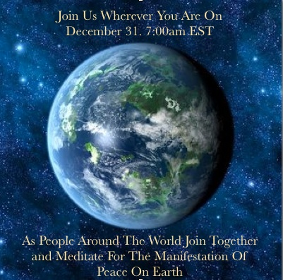

**You may want to begin your experience with beautiful music.
Deep Peace - New Thought Choir Music - by Bill Douglas (traditional Gaelic Blessing) - Bing video
Reiki music for world peace: Meditation music, reiki music, healing music, peaceful music 31603R - YouTube
The next two songs from the album “God Speaks!” by 2 Healing Hearts Ministry were performed at the 2019 Hour For Peace. See lyrics at the bottom of this document.
After the Storm - YouTubeAfter the Storm - YouTube
Sing My Songs (God Speaks) - YouTube
Hour For Peace NoCo 2025 Theme
Faithful Stewards of Peace Since 1986


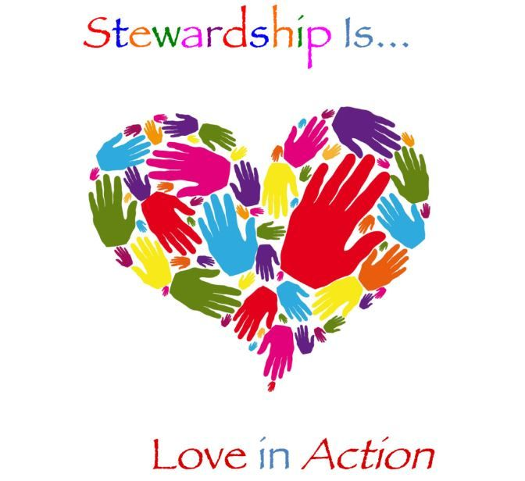

And More!
“Blessed are the Peacemakers, for they shall be called the Sons of God.”
Matthew 5:9
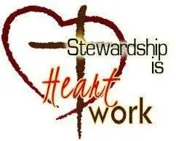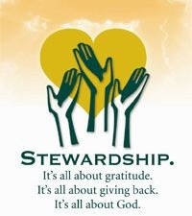

**40th Annual World Healing Peace Meditation
With Michelle Medrano & Chris Plym
Wednesday, December 31, 5 - 6 a.m. Mountain Standard Time.
Hosted by Mile Hi Church in Lakewood Colorado, join via Zoom.
World Healing Peace Meditation - Mile Hi Church



The World Healing Peace Meditation, aka the International Hour For Peace, was created by John Randolph Price in 1985 and is celebrated all over the world at Noon Greenwich Mean Time, which is 5 a.m. Mountain Standard Time. Hundreds of thousands will pray for peace at the same time—a powerful way to end the year.
Join more than 500 million people from an array of faith traditions and philosophies, across seven continents, meditating and praying for peace simultaneously. We begin at precisely the same moment all around the world in all the many languages to pray in the ways of their own traditions. We each affirm peace and commit to doing our part to heal the world. It is truly an amazing experience to sense the consciousness and the presence of hundreds of millions of people sharing in this meditation.
Join Zoom Meeting https://us02web.zoom.us/j/82199907366
Meeting ID: 821 9990 7366
John Randolph Price World Healing Meditation - www.quartus.org/world-healing-day/world-healing-meditation/ -

**For Catholics, this Holy Hour for Peace model from the U.S. Conference of Catholic Bishops is based on the ritual book “Holy Communion and Worship of the Eucharist Outside of Mass”. Holy Hour for Peace | USCCB

**Prayers for Peace from many faiths: www.hourforpeace.org/prayers.html
**Peace in Many Languages - www.hourforpeace.org/languages.html
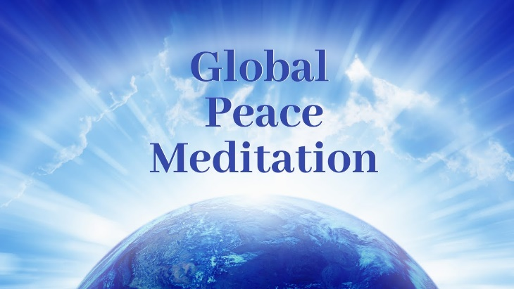

More Guided Meditations

**Guided Meditation for World Peace by Selomen
“This guided meditation will allow you to find peace within yourself and peace worldwide. There are several scientific experiments which has shown that many people meditating on peace can make a difference in local communities and globally. Join the movement for world peace!
https://www.youtube.com/watch?v=LBBMRfJxH5k

**Meditation for World Peace by Sarah Hall
“Join me in this meditation to lift our spirits towards personal and collective peace
on earth. You have the power to effect real change in this world simply by playing
the instrument of love that is your own heart.”
https://www.youtube.com/watch?v=OdnU2esw8Tk

**Silent Unity Meditations: Inner Peace

“You are invited to relax, take a deep breath, and pause in this moment

as you allow Spirit to restore your natural balance.”
https://www.unity.org/prayer/silent-unity-meditations/inner-peace
**Sarah Catoria’s World Healing Meditation
It focuses on sending healing energy to the earth, people and situations in need.
World Healing Guided Meditation With The Angels- Heal People, Animals, The Earth, Family & Yourself

**Global Heart of Peace Initiative
This initiative promotes peace and cooperation through meditation and community actions. It encourages individuals to engage in practices that reflect inner peace, which can contribute to a more harmonious world. It often hosts events and provides resources for meditation on peace
CSL Global Heart of Peace Initiative - Centers for Spiritual Living

“After the Storm” Lyrics
By Wahni Kay Santore and Rev. Dr. Victoria Gardner
Copyright 2020 “2 Healing Hearts” – All Rights Reserved

Verse 1
After the storm, there is New Light. After the storm, we’re alright.
After the storm, we find release. After the storm, there’s healing and peace.
After the storm . . . Hallelujah! After the storm . . . Hallelujah!
After the storm . . . . . Hallelujah!
Bridge 1
In the midst of the storm, we were falling apart.
But in the midst of our suffering, and broken hearts
Jesus was there with His Love and Care. Jesus was there with His Love and Care.
He is our Refuge and Shelter in the storm! Oh,
Hal . . lelu . . . jah! Hal . . lelu . . . jah! Hal . . lelu . . . jah!
Verse 2
After the storm, He opens our eyes. After the storm, we see New Life.
After the storm, we find new strength. After the storm, we find new hope.
After the storm . . . Hallelujah! After the storm . . . Hallelujah!
After the storm . . . . . Hallelujah!
Bridge 2
In the midst of the wind, raging waves, and rain;
In the midst of our sorrow, anguish, shame, and pain;
Jesus is with us all the way. Jesus is with us, come what may.
He calms the storms on the sea, and calms the storms in you and me!
Oh, Hal . . lelu . . . jah! Hal . . lelu . . . jah! Hal . . lelu . . . jah!
After the storm . . . Hallelujah! After the storm . . . Hallelujah!
After the storm . . . . . Hallelujah! Hallelujah! Hallelujah! Hallelujah!

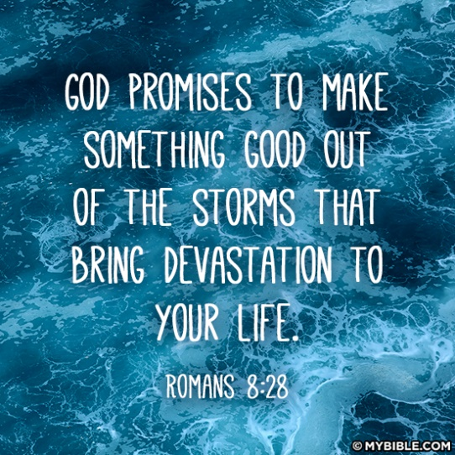
Sing My Songs (God Speaks) Lyrics

By Rev. Dr. Victoria A. Gardner, 6-18-2016

Copyright 2020 “2 Healing Hearts Ministry”, All Rights Reserved

Chorus:

Sing My Songs for all the ages. Sing My Songs for all the sages.
Sing My Songs of Love for all the earth.

Sing My Songs for all My children so they will know I love them.

Sing My Songs for all the ones who hurt.

Sing My Songs of Peace and Unity, of Beauty and Harmony,
My Songs of Truth for all the earth.

Sing My Songs for all the nations. Sing My Songs for all Creation.

Sing My Songs and know how much you’re worth.

Sing My Songs. Sing My Songs. Sing My Songs.

Verse:

Leaves realize they’re on the same branch.

Branches know they’re part of the tree.

Trees know they’re part of the same forest

And the forest and the earth are part of Me.

Each tiny drop of rain becomes part of the river,

And rivers always run to the sea.

All parts of Mother Earth connect to each other,

And you are all connected to Me.

Repeat Chorus

Last Chorus

Sing My Songs for all the ages. Sing My Songs for all the sages.
Sing My Songs of Love for all the earth.

Sing My Songs for all My children just to let them know I love them.

Sing My Songs for all the ones who hurt, and hurt, and hurt, and hurt.

Sing My Songs of Peace and Unity, of Beauty and Harmony,
My Songs of Truth for all the earth.

Sing My Songs for all the nations. Sing My Songs for all Creation.

Sing My Songs and know how much you’re all worth.

Sing My Songs. Sing My Songs. Sing My Songs. Sing My Songs.

“Sing My Songs” was inspired by these scriptures:

“Let the heavens be glad, and let the earth rejoice; Let the sea roar, and all the things it contains; Let the fields be jubilant, and everything in them; let all the trees of the forest sing for joy.” Psalm 96:12

“Let the trees of the forest sing; let them sing for joy before the Lord.” 1 Chronicles 16:33
“Let the rivers clap their hands; Let the mountains sing together for joy and delight.” Psalm 98:8
“All the rivers flow into the sea, yet the sea is never full. To the place where the rivers come from, there they return again.” Ecclesiastes 1:7

“O sing to the Lord a new song; Sing to the Lord, all the earth!” Psalm 96:1
“Let us come before His Presence with a song of thanksgiving; Let us shout joyfully to Him with songs.” Psalm 95:2
“You, Lord, are my hiding place; You will protect me from trouble and surround me with songs of deliverance.” Psalm 32:7
“The Lord will save me, and we will sing with stringed instruments all the days of our lives in the house of the Lord.” Isaiah 38:20

“The Lord your God is with you, the Mighty Warrior who saves. He will take great delight in you; He will quiet you with His Love; He will rejoice over you with singing.” - Zephaniah 3:17

